|  |
| --- |
| **Exercises from old exams to chapters in B & W.** |

|  |
| --- |
| **Chapter 11 and 12** |

**Exercise 1**

Answer the following statements as **true** or **false**, and explain why. Write no more than three sentences on each question.

1. The marginal propensity to consume must be larger than one.
2. An increase of one unit in the government spending leads to an increase of more than one unit in equilibrium output in an IS-TR model.
3. An increase in government spending shifts the IS curve to the left.
4. If the central bank reduces its target rate the TR schedule shifts upwards and to the left.
5. An appreciation leads to an immediate improvement in the competitive ability.
6. The Taylor rule implies that if inflation is below target, the central bank should increase the nominal interest rate above the desired level.

**Exercise 2**

1. Use a small open economy version of the IS-TR model, known as the Mundell-Fleming model to explain devaluation under fixed exchange rates.
2. As a follow up to question a), explain what the central bank must do to keep the domestic interest rate equal to the foreign rate of return?

**Exercise 3**

1. Define the curves in a IS TR model and explain the slope of the curves (ignore international trade in financial assets).
2. Explain what will happen if the economy is above the IS curve and above the TR curve.
3. Use the IS TR model to discuss the effect of an expansionary fiscal policy.

**Exercise 4**

Consider a small open economy version of the IS-TR model, known as the Mundell-Fleming model.

1. Explain the IS curve, the TR curve and the international financial markets (IFM) line.
2. In a Mundell Fleming model, explain the loss of monetary policy autonomy under a fixed exchange rate regime.
3. In a Mundell Fleming model, explain a demand shock under flexible exchange rates.

**Exercise 5**

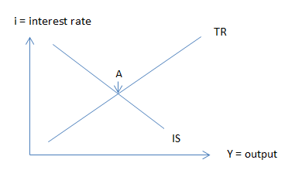Suppose the goods market and the money market can be explained by the figure at the right hand side (IS-TR model).

1. Define the curves and explain point A
2. Use the model to explain the effect on output of a real exchange rate decrease.
3. Explain part b) more in detail by dividing the total effect on output into a multiplier effect (no interest rate change) and a central bank response.

**Exercise 6**

1. Define the curves in a Mundell-Fleming model (the IS-TR-IFM model).
2. Explain why it is important to distinguish between the types of exchange rate regime when discussing the effect of a fiscal policy.

**Exercise 7**

1. Explain two polar cases when it comes to exchange rate regimes and give examples of countries that has chosen each type.
2. Define the curves in a Mundell-Fleming model (the IS-TR-IFM model).
3. Explain by using the model from b), why it is important to distinguish between types of exchange rate regimes when to discuss the effect of an expansionary monetary policy?
4. Explain by using the model from b) the following quotation: “fixed but adjustable exchange rates provide some limited degree of monetary effectiveness.

**Exercise 8**

1. Explain the Keynesian multiplier.
2. Define the Taylor rule and explain how it is used differently in the short run compared to the long run.
3. Explain by using a Mundell-Fleming model (the IS-TR-IFM model) the effect of an expansionary monetary policy under flexible exchange rates. Refer to fig 1 if desired. 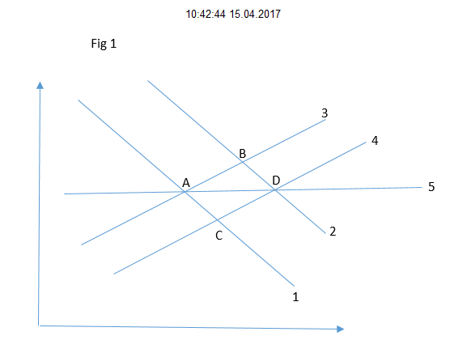

**Exercise 9**

What makes the IS curve flatter and how will this affect an expansionary fiscal policy according to the model?

**Exercise 10**

1. What are the main assumptions when we study the short run behaviour of the economy?
2. What are the main factors and how do they drive private consumption?
3. Explain the situation if we are off the IS curve.